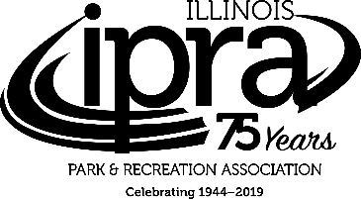
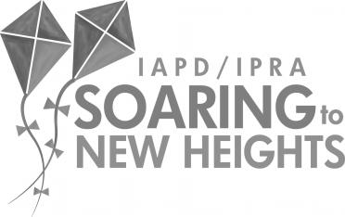
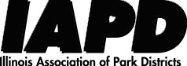

2019 Program Addendum:

CANCELLATIONS

Friday, January 25, 1:00 pm – 2:15 pm:
CANCELLED: Session #911, Developing Effective In-House Program, Class, and Facility Participant Surveys, Randolph 1AB, East Tower, Bronze Level

Saturday, January 26, 10:15 am – 11:30 am:
CANCELLED: Session #612, Recreation Center Design Trends & Customer Service Experiences That Create Vitality & Revenue, Michigan 1B, East Tower, Bronze Level

SPEAKER UPDATES

Thursday, January 24, 1:30 pm – 4:30 pm:
- Session #302, Are We Having Any Fun Yet? Strategies to Prevent Burnout
Speaker change: Colonel Jill Morgenthaler, Global Speaker, Leadership Expert, Author replaces Rita Emmett

Friday, January 25, 8:15 am – 9:30 am:
- Session #109, Understanding Your Role in Having a Successful Park Foundation
Speaker changes: Jill Applebee, Director, Decatur Park District Foundation, Ron Lehman, Director, National Association of Park Foundations and Don Jessen, Chairman, Emeritus, National Association of Park Foundations replace Donald Ortale

Friday, January 25, 9:45 am – 11:00 am:
- Session #111, Legal/Legislative, Part II
Speaker added: Christine A. Walczak, Attorney, Tressler LLP joins Andrew Paine

- Session #318, Might an Alternative Staffing Model Make Sense in Your Organization?
Speakers added: Ron Salski, Executive Director, Lake Bluff Park District and Cheryl Mosqueda, Owner, Mosqueda Consulting join Michael Earl

Saturday, January 26, 10:15 am – 11:30 am:
- Session #114, Use of Video Surveillance in Parks and Facilities
Speaker added: Robert Newport, Executive Director, Round Lake Area Park District, joins Scott Puma and Megan Mack

- Session #317, Unplugged Cyber: A Common-Sense Approach to Cybersecurity
Speaker added: Diborah Berhanu, Attorney, Tressler LLP joins Todd Rowe

Saturday, January 26, 12:30 pm – 1:45 pm:
- Session #315, FMLA (Why That Is Not a Password to Get Out of Work)
Speaker change: ShawnTe Raines, Attorney, Ancel Glink replaces Darcy Proctor

Saturday, January 26, 2:00 pm – 3:15 pm:
- Session #113, Not in my Park: Regulating Controversial Park Activities
Speaker changes: David Warner, Of Counsel, Ancel Glink joins Erin Pell; Daniel Bolin and Kurt Asprooth will not be presenting

2019 Exhibit Addendum:

NEW EXHIBITOR

Cardno – Mike Glester
Booth #(s): 257
Environmental/Energy Services
6605 W. Steger Road, Suite A
Monee, IL 60449
P: (708) 534-3450
W: cardno.com
E: mike.glester@cardno.com
Cardno is a leader in delivering scientific and sustainable environmental solutions for our clients. We work to restore the physical and natural environment, improve ecological and human health, and positively impact the lives of our employees and our communities.

