2019 Student Volunteer Form  Deadline: January 7, 2019 |  | 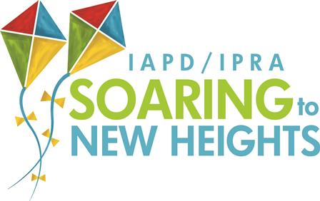
If you are interested in volunteering at the 2019 Conference, please complete this form and return to Carlo Capalbo at capalbo@plainfieldparkdistrict.com  Please submit this form by January 7, 2019. As a student volunteer, you are entitled to a FULL refund of your conference registration. You will receive your refund check (or credit to your credit card) within six weeks following the conference and it will be mailed to the address used when you registered for conference. |  | In order to receive a refund, you must complete the following requirements:  - You must be a full-time student.  - You must be a member of IPRA. Please see your student advisor for information on membership.  - You must be registered and have paid for the conference.  - You must be signed up to work at least 4 volunteer hours during the conference.  - You must complete the volunteer sign-in/out sheet, and a member of the Operations Committee will verify that you have completed your required volunteer hours.
Full Name
School
Cell Phone
E-Mail Address

Listed below are the different shifts available for Conference Operations. Volunteer duties include directing attendees to the various session rooms; putting up signage throughout the hotel; assisting session moderators/room hosts; and other duties as assigned. To receive a refund, you MUST complete a total of 4 volunteer hours (minimum of 2 shifts). Refund check will be processed and mailed within six weeks following conference.

Please check the shifts below that you are available. The earlier we receive your availability, the better chance you have to work the shifts you request. Requests will be filled on a first-come, first-served basis. Volunteers will be scheduled to ensure all times are filled. You will be contacted before conference to confirm your schedule.

Thursday, January 24 Friday, January 25 Saturday, January 26
☐ 8-10am ☐ 7:30-9:30am ☐ 9:30-11:30am
☐ 10am-12pm ☐ 9:00-11:00am ☐ 10:30am-12:30pm
☐ 12-2pm ☐ 10:15am-12:15pm (High Need) ☐ I can work any shift
☐ 2-4pm ☐ 12:30-2:30pm
☐ I can work any shift ☐ 1:30-3:30pm (High Need)
☐ 3:30-5:30pm
☐ I can work any shift

☐ Please check here if you are comfortable in a public speaking role.

By checking the box below, you are confirming that you are a member of IPRA, registered for 2019 Conference, and will send a copy of your class schedule or proof of full-time status. You also understand that you may be called to work any of the shifts that you indicated above (up to 4 hours). Please contact Carlo Capalbo with any questions, (815) 436-8812 or capalbo@plainfieldparkdistrict.com.

☐ I agree to the terms and conditions listed above.

Signature of Applicant: ____________________________________________________ Date: ____________________

