2018 Student Volunteer Form  Deadline: January 5, 2018 |  | 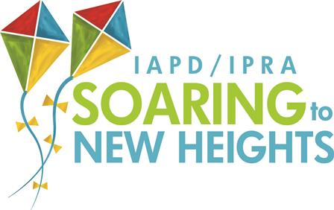
If you are interested in volunteering at the 2018 Conference, please complete this form and return to Andrew Dallner at adallner@ofallon.org  Please submit this form by January 5, 2018. As a student volunteer, you are entitled to a FULL refund of your conference registration. You will receive your refund check within six weeks following the conference and it will be mailed to the address used when you registered for conference. |  | In order to receive a refund, you must complete the following requirements:  - You must be a full-time student.  - You must be a member of IPRA. Please see your student advisor for information on membership.  - You must be registered and have paid for the conference.  - You must be signed up to work at least 4 volunteer hours during the conference.  - You must complete the volunteer sign-in/out sheet, and a member of the Operations Committee will verify that you have completed your required volunteer hours.
Full Name
School
Cell Phone
E-Mail Address

Listed below are the different shifts available for Conference Operations. Volunteer duties include directing attendees to the various session rooms; putting up signage throughout the hotel; tabulating session survey results; and assisting session moderators and room hosts. To receive a refund, you MUST complete a total of 4 volunteer hours. You will be contacted before conference to confirm your schedule. The earlier we receive your availability, the better chance you have to work the shifts you are available. Please check the shifts below that you are available. You will need to work a minimum of 2 shifts in order to receive a refund. You will receive your refund check within six weeks following conference.

Thursday, January 18 Friday, January 19 Saturday, January 20
_____8-10am _____7:30-9:30am _____9:30-11:30am
_____10am-12pm _____9:00-11:00am _____10:30am-12:30pm
_____12-2pm _____10:15am-12:15pm (High Need) _____I can work any shift
_____2-4pm _____12:30-2:30pm
_____I can work any shift _____1:30-3:30pm (High Need)
_____3:30-5:30pm
_____I can work any shift

By checking the box below, you are confirming that you are a member of IPRA, registered for 2018 Conference, and will send a copy of your class schedule or proof of full-time status. You also understand that you may be called to work any of the shifts that you indicated above (up to 4 hours). Please contact Andrew Dallner with any questions, (618) 624-0139 or adallner@ofallon.org.

______ I agree to the terms and conditions listed above.

Signature of Applicant: ___________________________________________ Date: ____________________

